**INSERTION SORT**

CODE:

#include<stdio.h>

#include<time.h>

#include<stdlib.h>

void insertion(int arr[],int n){

int j;

for (int i=1;i<n;i++){

int temp=arr[i];

j=i-1;

while(arr[j]>temp && j>=0){

arr[j+1]=arr[j];

j--;

}

arr[j+1]=temp;

}

}

int main(){

printf("55000\n");

clock_t t;

int n,a[550000],b;

for(int i=0;i<55000;i++){

a[i]=rand();

}

t=clock();

insertion(a,55000);

t=clock()-t;

double t1=((double)t);

printf("average %f\n",t1);

for(int i=0;i<55000;i++){

a[i]=i;

}

t=clock();

insertion(a,55000);

t=clock()-t;

double t2=((double)t);

printf("best %f\n",t2);

for(int i=0;i<55000;i++){

a[i]=n;

n--;

}

t=clock();

insertion(a,55000);

t=clock()-t;

double t3=((double)t);

printf("worst %f\n",t3);

return 0;

}

OUTPUT:

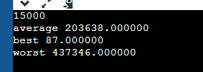

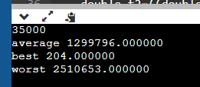

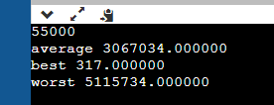

**SELECTION SORT**

CODE:

#include <stdio.h>

#include<time.h>

#include<stdlib.h>

void swap(int *xp, int *yp)

{

int temp = *xp;

*xp = *yp;

*yp = temp;

}

void selectionSort(int arr[], int n)

{

int i, j, min_idx;

for (i = 0; i < n-1; i++)

{

min_idx = i;

for (j = i+1; j < n; j++)

if (arr[j] < arr[min_idx])

min_idx = j;

if(min_idx != i)

swap(&arr[min_idx], &arr[i]);

}

}

void printArray(int arr[], int size)

{

int i;

for (i=0; i < size; i++)

printf("%d ", arr[i]);

printf("\n");

}

int main(){

clock_t t;

int n,arr [150000],b;

scanf("%d",&n);

int x=n;

for(int i=0;i<n;i++){

arr[i]=rand();

}

t=clock();

selectionSort(arr,n);

t=clock()-t;

double t1=((double)t);

printf("average %f\n",t1);

for(int i=0;i<n;i++){

arr[i]=i;

}

t=clock();

selectionSort(arr,n);

t=clock()-t;

double t2=((double)t);

printf("best %f\n",t2);

for(int i=0;i<n;i++){

arr[i]=x;

x--;

}

t=clock();

selectionSort(arr,n);

t=clock()-t;

double t3=((double)t);

printf("worst %f\n",t3);

return 0;

}

OUTPUT:

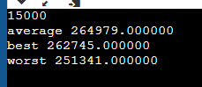

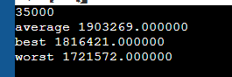

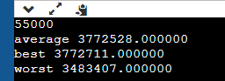

Observation Table:

|  |  |  |  |  |  |  |  |  |  |
| --- | --- | --- | --- | --- | --- | --- | --- | --- | --- |
|  |  | 15000 |  |  | 35000 |  |  | 55000 |  |
|  | best | average | worst | best | average | worst | best | average | worst |
| Insertion |  |  |  |  |  |  |  |  |  |
| Selection | 262745 | 264979 | 251341 | 1816421 | 1903269 | 1721572 | 3772711 | 3772528 | 3483407 |